Nested if

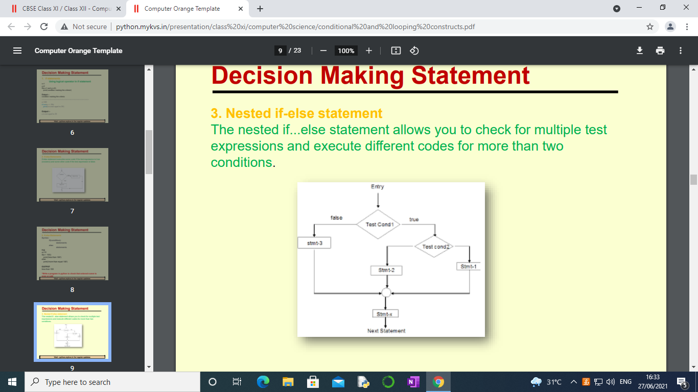

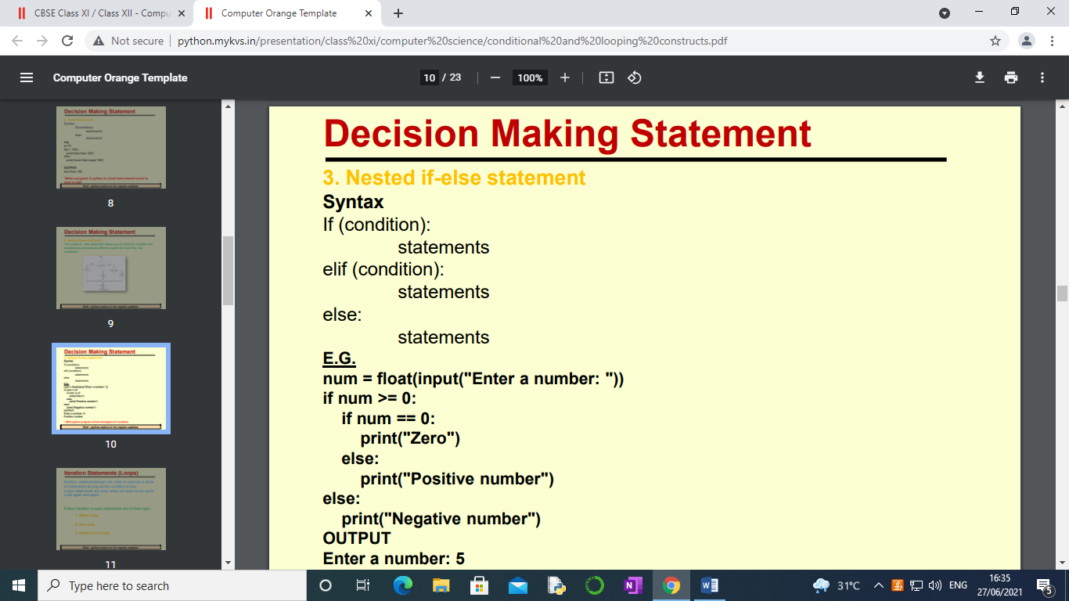

'''#largest of three no.s

a=int(input("enter first"))

b=int(input("enter second"))

c=int(input("enter third"))

if a>b and a>c:

print(" first no.is grteatest")

elif b>c and b>a:

print(" second no.is grteatest")

elif c>a and c>b:

print("third")

else:

print("equal")

#another way largest of three no.s

a=int(input("enter first"))

b=int(input("enter second"))

c=int(input("enter third"))

max=a

if b>max:

max=b

if c>max:

max=c

print(max)

'''

num=int(input("enter number"))

if num<0 or num>999:

print("invalid number")

elif num<10:

print("one digit")

elif num<100:

print("two digit")

else:

print("three digit")

Nested if conditional statement-

another if inside one if/elif/else statement

num=int(input("enter number"))

if num<0 or num>999:

print("invalid number")

else:

if num<10:

print("one digit")

elif num<100:

print("two digit")

else:

print("three digit")

#WAP to check whether the character is vowel or consonant

a=input("enter one character")

if a=='a' or a=='e' or a=='i' or a=="A":

print("char is vowel")

Write a program to input a character and check whether it

is a digit, uppercase letter ,lowercase letter or any other character /symbol.

(ascii value: uppercase:65-90, lowercase:97-122, digit:48-57)

Write a program to check whether a person is eligible for entrance according to

following conditions:

i) If a person is male, unmarried and age is more than 25

ii) If a person is male and married

iii) If a person is female, unmarried and age is more than 22

iv) If a person is female, married and age is less than 35

gender, status,age

H.W.

Write a program to input the salary of an employee

and calculate the bonus and find the net salary after adding the bonus

according to the following data:

Basic salary Bonus

Above 30000 20%

Between 20000 and 30000 15%

Below 20000 10%